Guide for getting your WhatsApp messages
Minimum requirements:
- Access to a phone that has the WhatsApp app installed and at least one active group or conversation.
Step 1: Open WhatsApp.
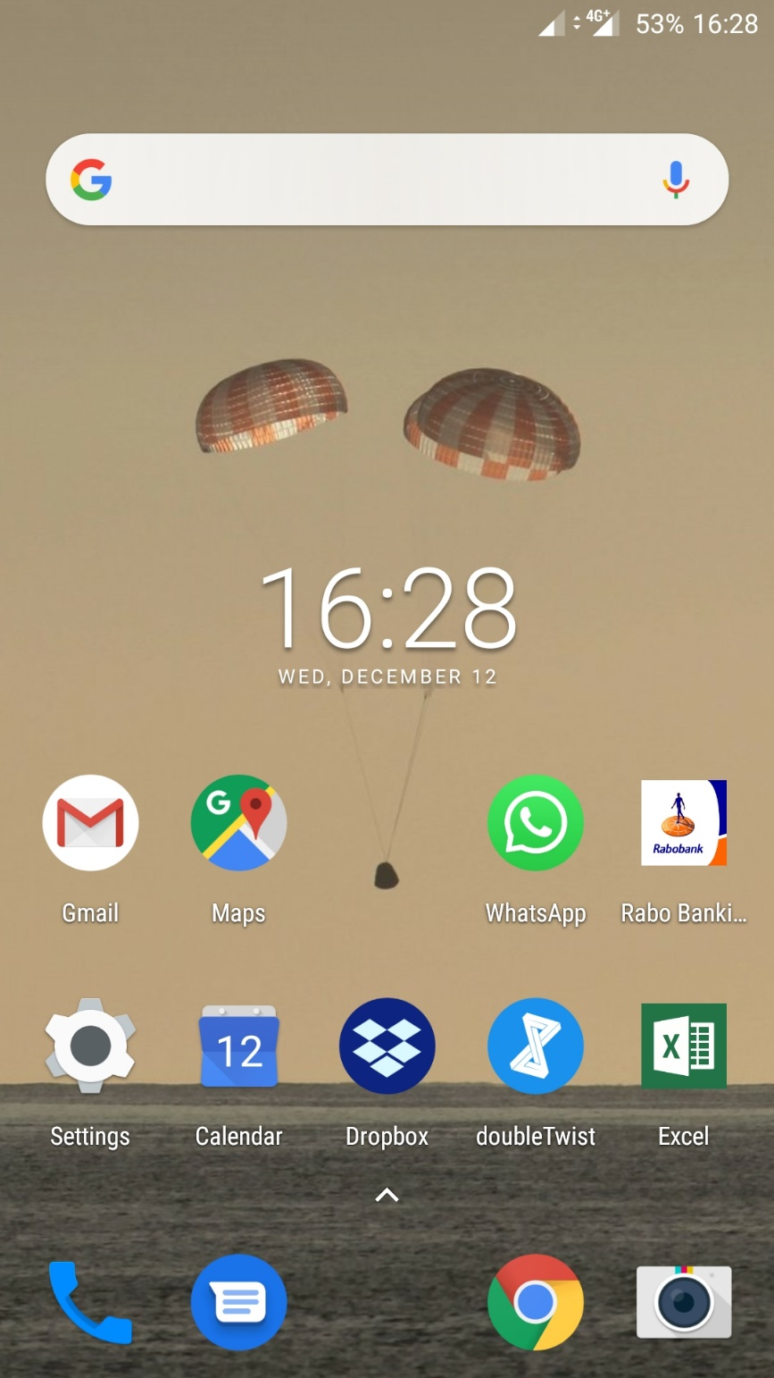

Step 2: Open the chat you want to export.
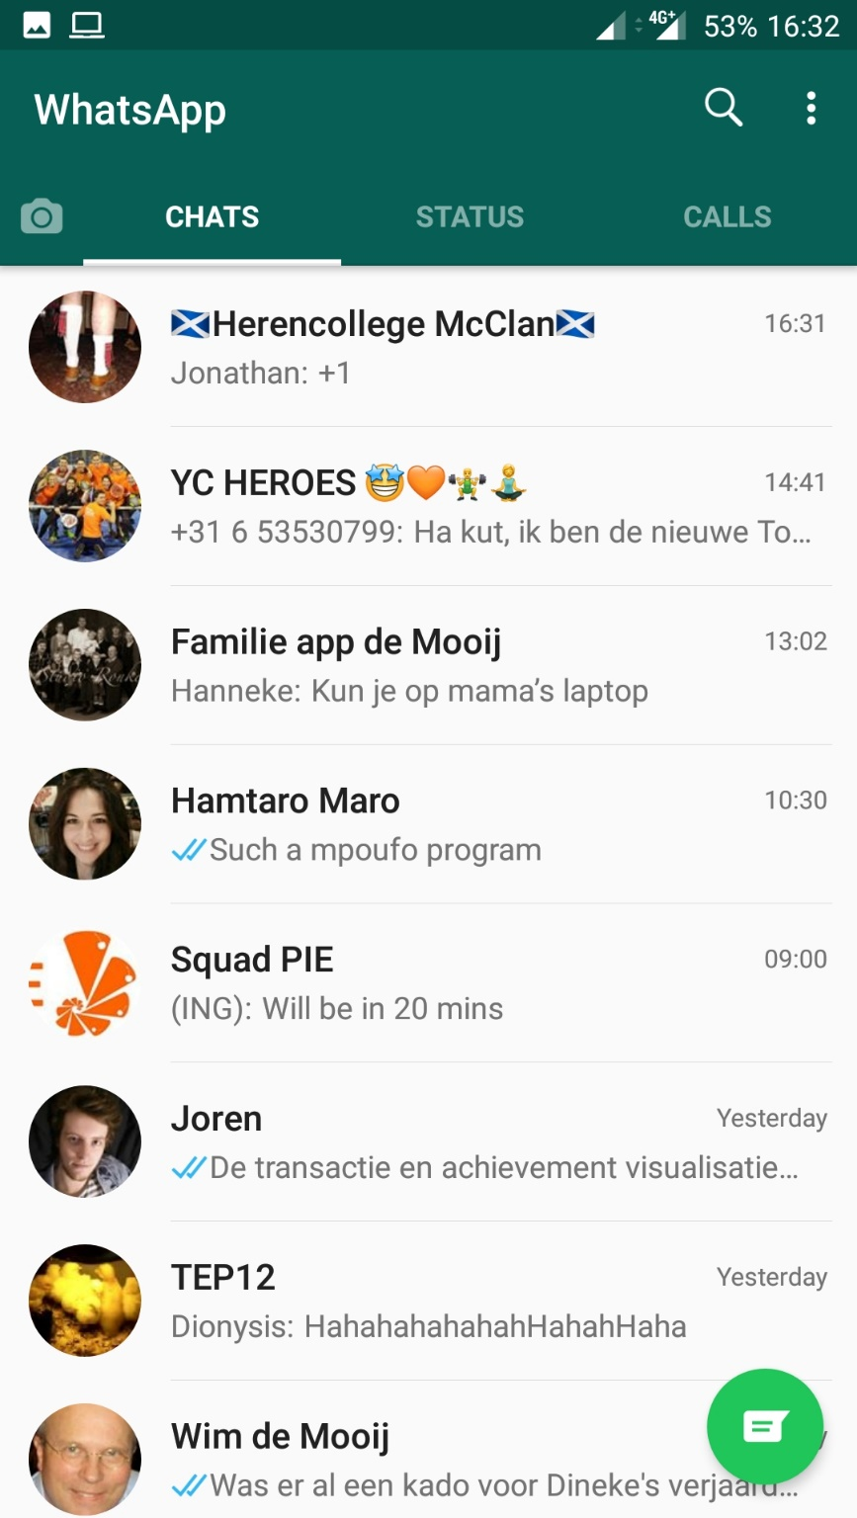

Step 3: Press the vertical ellipsis to open the menu:


Step 4: Press “More”:
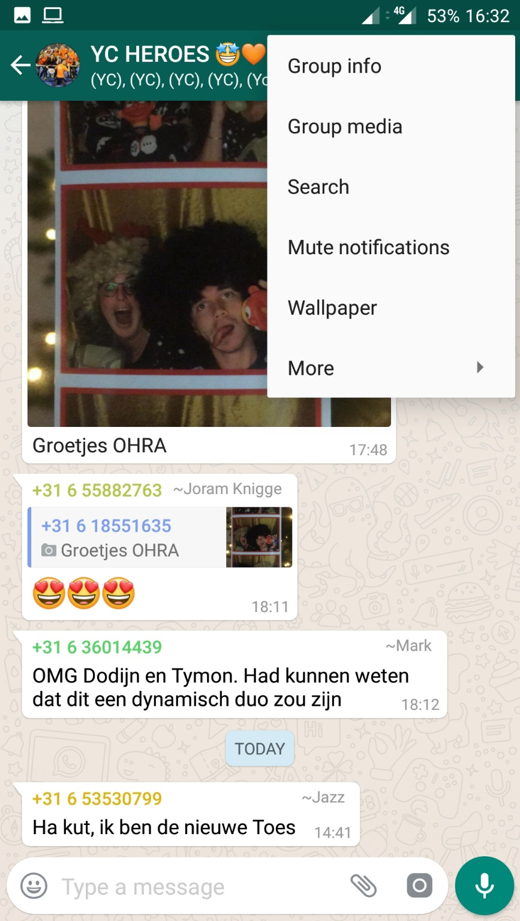

Step 5: Press “Export chat”:
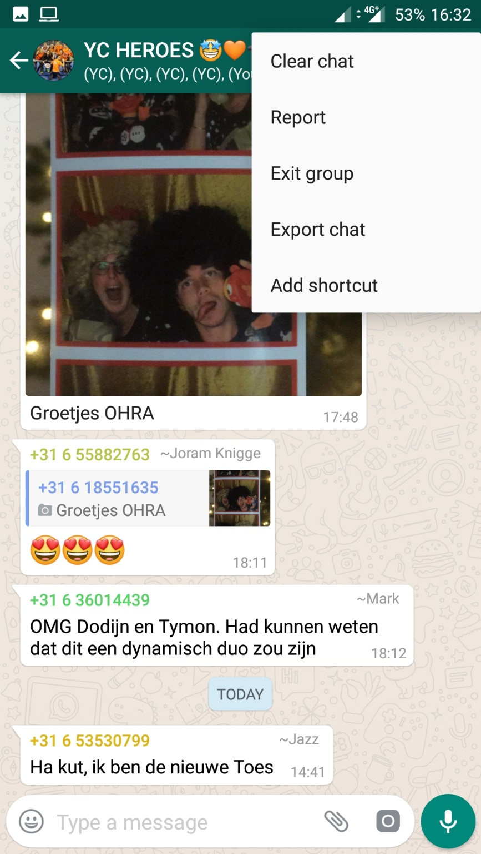

Step 6: Press “WITHOUT MEDIA”:
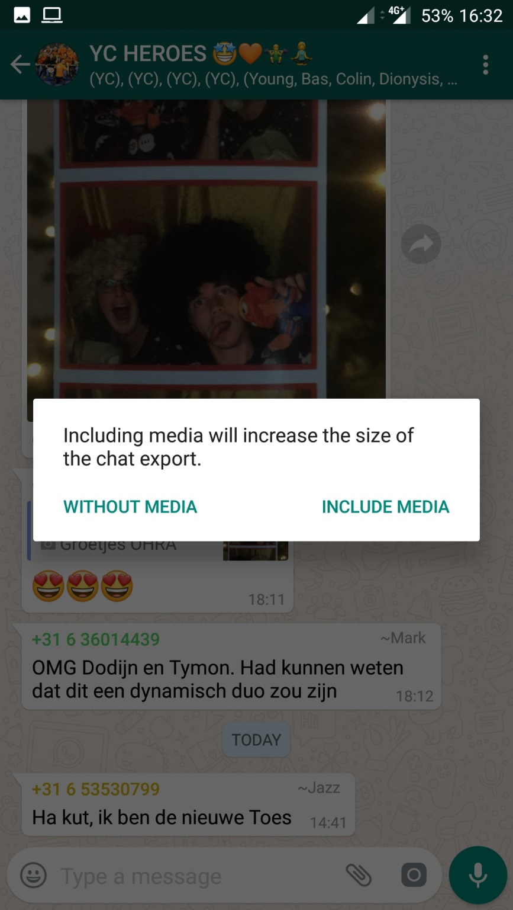

Step 7: Press “Gmail”:
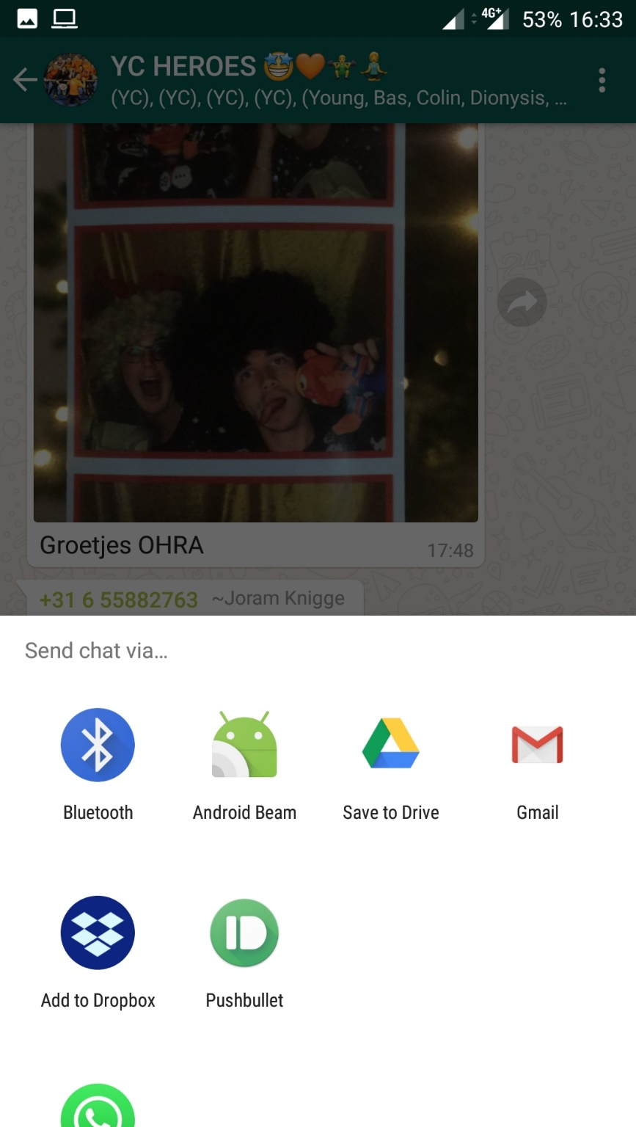

Step 8: Enter your own email address and send:
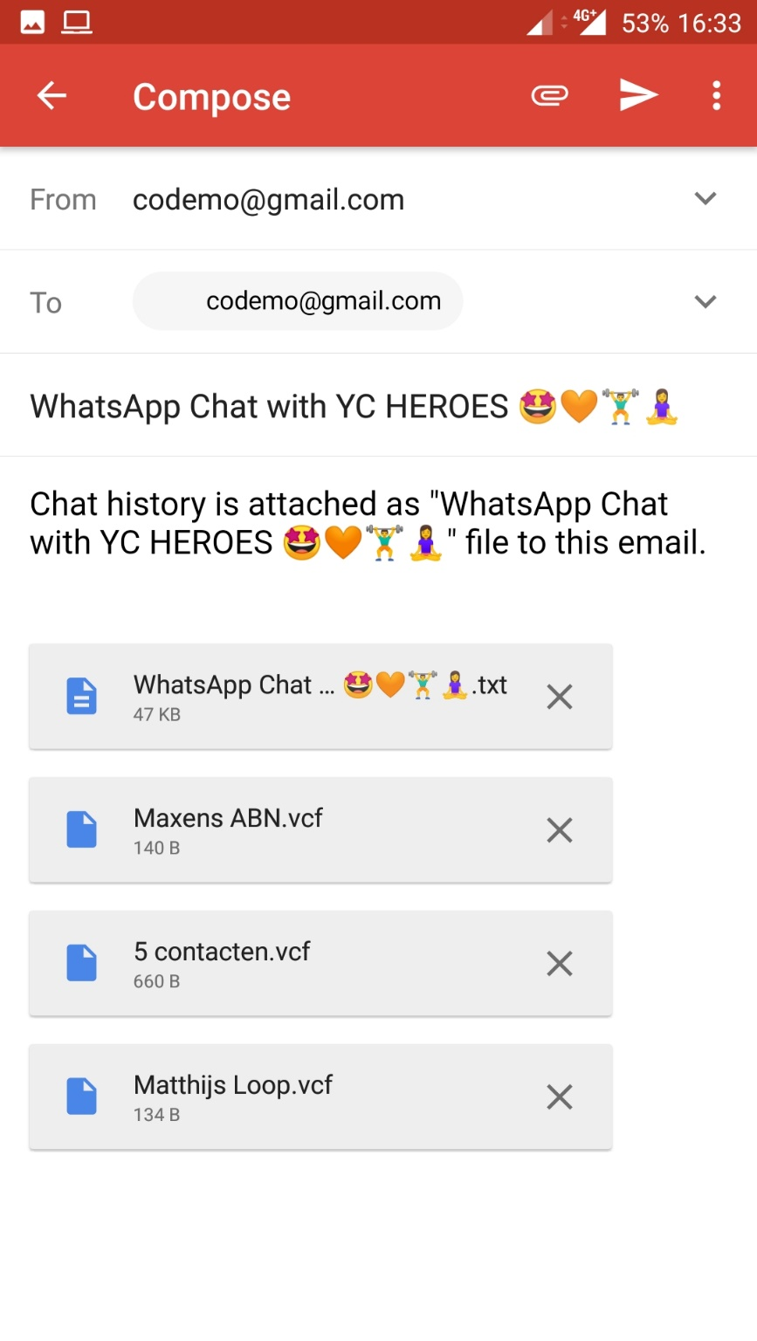
2

1

